CHAPTER 4: CODING AND TESTING

4.1 INTRODUCTION
This chapter is mainly concerned with coding and testing the system. Coding involves turning program into specific instructions that are executed by the computer system. The system database was the first to be constructed. All the elements in the data dictionary conceptualized during the database design were mapped into the relevant tables. The graphical user interfaces was constructed also. The system functionalities were developed as modules. The modules are integrated into one working system.

4.2. TECHNICAL DOCUMENTATION
Technical documentation is critical to the success of any software. This section focuses on the arrangement of the code that was developed for the system to function. The section stresses on the cod snippet of the system rather than the entire code.

4.2.1. Database connection

Imports MySql.Data.MySqlClient
Module db_connect
Dim MysqlConn As New MySqlConnection

Public Function myconn() As MySqlConnection

Return New MySqlConnection(My.Settings.mydbConnection)

End Function
End Module
In order for user to add a new user into the system he or she need to connect to database. Code above shows the method used to connect to database using MySQL Client driver.

4.2.2. User authentication
Private Sub Button1_Click_1(sender As Object, e As EventArgs) Handles btnLog.Click
If txtUser.Text = "" Then
lblUser.Text = "*Username Required"
lblUser.Visible = True
lblPass.Visible = False
ElseIf txtPass.Text = "" Then
lblPass.Text = "* Password is Required"
lblPass.Visible = True
lblUser.Visible = False

Else
' lblsuccess.Text = "You logged in Successfully"
sql = "SELECT * FROM `admin` WHERE `username`='" & txtUser.Text & "' AND `password`='" & txtPass.Text & "' "
feesfindthis(sql)
If GetNumRows() = 1 Then
MsgBox("Logged in Successfully", MsgBoxStyle.Information)
LoadSingleResult("login")

Else
lblError.Text = "Username or Passwrord is not correct, Please try again!!"
lblError.Visible = True

End If

End If
End Sub

4.2.3. Student registration

Private Sub btnReg_Click(sender As Object, e As EventArgs) Handles btnReg.Click
If btnReg.Text = "Register" Then
feesfindthis("SELECT COUNT(*) FROM `student_details` WHERE `regNumber`='" & txtReg.Text & "'")

If GetCount() > 0 Then
MsgBox("School Id Number is already exist Please try something new!")
lblError.Text = "No student has been added!"
lblError.Visible = True
Else

If txtReg.Text = "" Then
MsgBox("Reg Number is Required!")
ElseIf txtFname.Text = "" Then
MsgBox("Name is Required!")
ElseIf txtSurname.Text = "" Then
MsgBox("Surname is Required!")
ElseIf txtAddress.Text = "" Then
MsgBox("Address is Required!")
ElseIf txtNational.Text = "" Then
MsgBox("Nationality is Required!")
ElseIf txtFather.Text = "" Then
MsgBox("Father's name is Required!")
ElseIf txtOcpy.Text = "" Then
MsgBox("Occupation is Required!")
ElseIf txtDOB.Text = "" Then
MsgBox("Date of Birth is Required!")
ElseIf txtPhone.Text = "" Then
MsgBox("Phone Number is Required!")
ElseIf cboClass.Text = "" Then
MsgBox("Please select class!")
ElseIf cboGender.Text = "" Then
MsgBox("Please select gender!")
ElseIf cboTerm.Text = "" Then
MsgBox("Please select School Term!")

Else
issucess = fees_insert("INSERT INTO `student_details` (`regNumber`, `name`, `surname`,`dateOfBirth`, " &
" `gender`, `nationality`, `class`, `term`, `address`, `fatherName`, `occupation`, `phone`,`date_registered`) " &
" VALUES ('" & txtReg.Text & "','" & txtFname.Text & "', '" & txtSurname.Text & "', '" & txtDOB.Text & "', '" & cboGender.Text & "', '" & txtNational.Text & "', " &
" '" & cboClass.Text & "', '" & cboTerm.Text & "', '" & txtAddress.Text & "', '" & txtFather.Text & "', '" & txtOcpy.Text & "', '" & txtPhone.Text & "','" & dpRegistered.Text & "');")
If issucess = True Then

MsgBox("New student has been added successfully!")
Fee_payement_Page.Show()
Me.Hide()
Fee_payement_Page.txtReg.Text = txtReg.Text
Fee_payement_Page.txtFullN.Text = txtFname.Text & " " & txtSurname.Text
Fee_payement_Page.cboClass.Text = cboClass.Text
Fee_payement_Page.cboTerm.Text = cboTerm.Text
Fee_payement_Page.txtCashName.Text = Main_Page.btnLogout.Text
4.2.4. Fees collection
If btnFeePay.Text = "Pay Fees" Then
'c1
If txtAmt.Text = "" Then

MsgBox("Please amount of fees paid is Required!", MsgBoxStyle.Critical)
ElseIf txtRecept.Text = "" Then
MsgBox("Please Receipt Number is Required!", MsgBoxStyle.Critical)
ElseIf txtBalance.Text = "" Then
MsgBox("Please make sure you have clicked button calculate fess before make payment", MsgBoxStyle.Critical)
Else
issucess = fees_insert("INSERT INTO `payment_fees` (`receiptNumber`,`regNumber`, `fullName`, `term_paid`,`date_paid`, " &
" `fees_paid`, `amount_left`, `class`, `isFullyPaid`,`Cashier`) " &
" VALUES ('" & txtRecept.Text & "','" & txtReg.Text & "','" & txtFullN.Text & "', '" & cboTerm.Text & "', '" & dpRegistered.Text & "', '" & txtAmt.Text & "', '" & txtBalance.Text & "','" & cboClass.Text & "', " &
" '" & cboStatus.Text & "','" & txtCashName.Text & "');")
If issucess = True Then
fees_insert("INSERT INTO `tblbackup` (`receiptNumber`,`regNumber`, `fullName`, `term_paid`,`date_paid`, " &
" `fees_paid`, `amount_left`, `class`, `isFullyPaid`,`Cashier`) " &
" VALUES ('" & txtRecept.Text & "','" & txtReg.Text & "','" & txtFullN.Text & "', '" & cboTerm.Text & "', '" & dpRegistered.Text & "', '" & txtAmt.Text & "', '" & txtBalance.Text & "','" & cboClass.Text & "', " &
" '" & cboStatus.Text & "','" & txtCashName.Text & "');")

MsgBox("New student fees has been paid successfully, you may print receipt")

4.2.5. Listing registered students

Private Sub StudentLists_Load(sender As Object, e As EventArgs) Handles MyBase.Load
feesfindthis("SELECT `regNumber`, `name`,`surname`,`dateOfBirth`, `gender`, `nationality`, `class`, `term`, `address`, `fatherName`,`occupation`,`phone`,`date_registered` FROM `student_details`")
LoadData(studentGrid, "STUDENTLIST")

End Sub

4.2.6. Listing students with arrears
Private Sub Arrears_Shown(sender As Object, e As EventArgs) Handles Me.Shown
feesfindthis("SELECT*FROM payment_fees WHERE isFullyPaid= 'NO'")
LoadData(DataArrears, "payment")
Dim kl = GetTotalArrears()
lblTotal.Text = kl

End Sub

4.3. UNIT AND SYSTEM TESTING
Unit testing is a software development process in which the smallest testable parts of an application, called units, are individually and independently scrutinized for proper operation. Performing individual test on the piece of code using unit testing verifies the correctness of test code. Unit testing also verifies the accuracy of the each unit. The following tests were performed:

Test 1: Invalid login
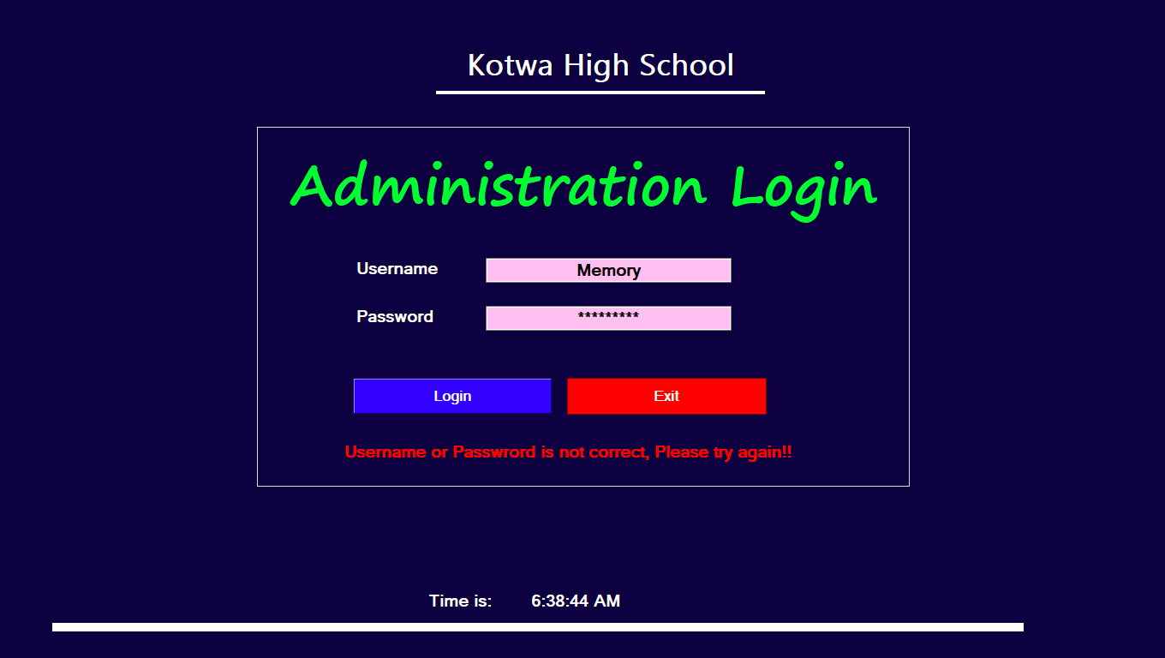

Test 2: Successful registration
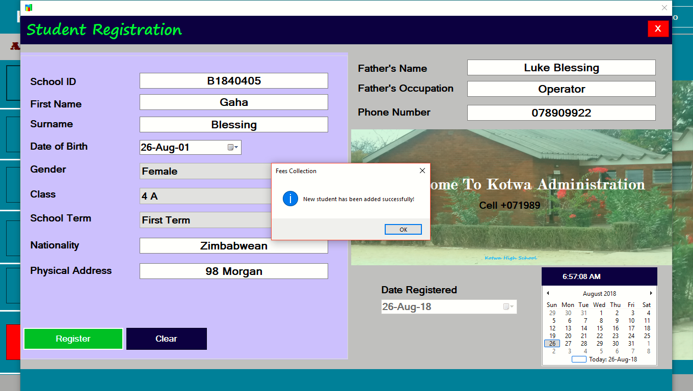

Test 3: Student record already exist

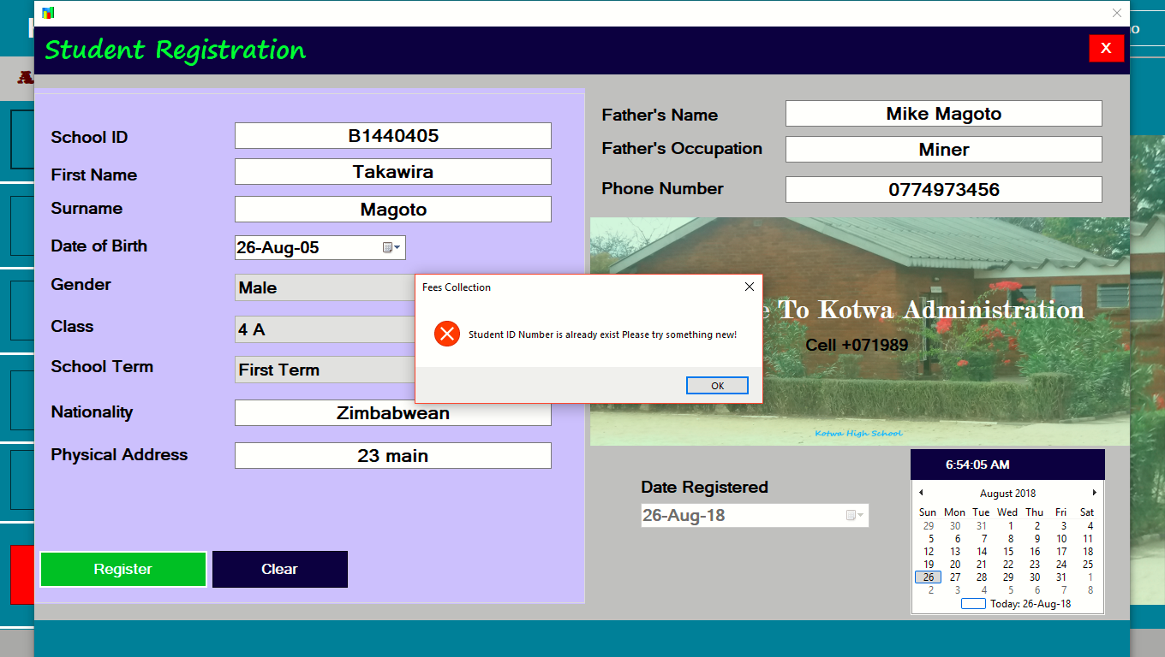
Test 4: Record not found
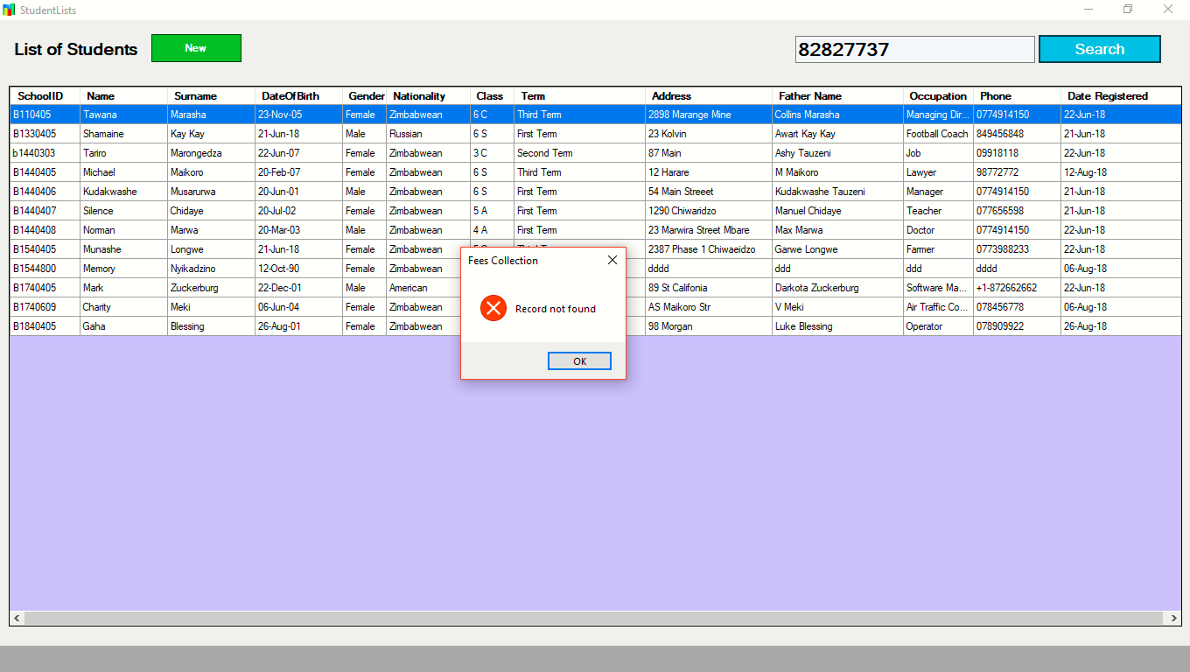

4.4: USER TESTING
User testing is a technique used in user-centered interaction design to evaluate a system by testing it on users. This can be seen as an irreplaceable usability practice, since it gives direct input on how real users use the system. User testing was done by focusing on the objectives of the system and the following test results were observed.
Objective one: Enable the user to add student details to the system
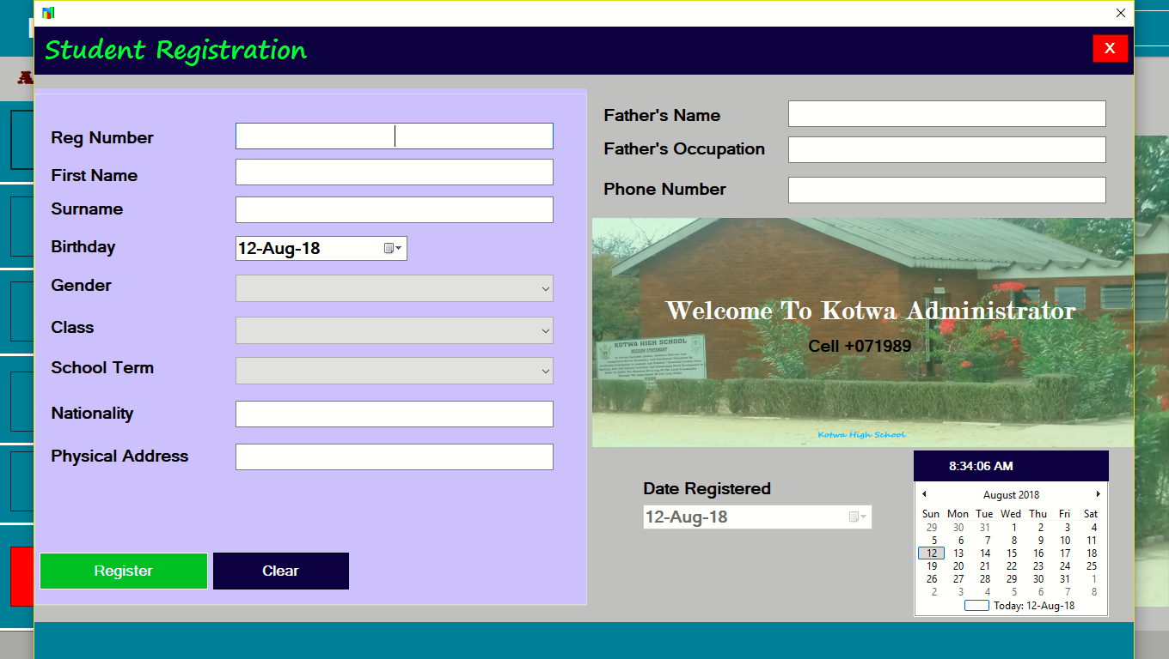

Objective 2: Enable the user to add new student’s school fees details to the system

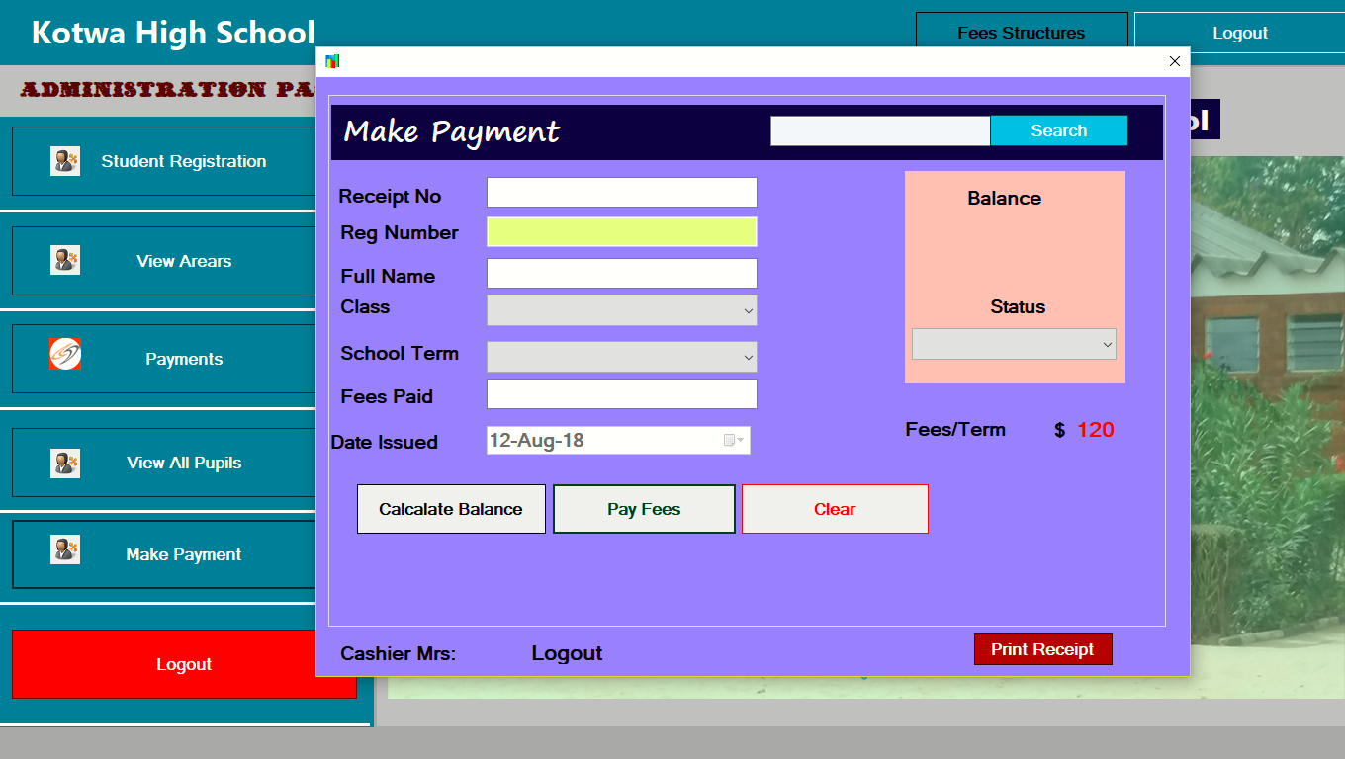

Objective 3: Enable the user to view all the details of student payments
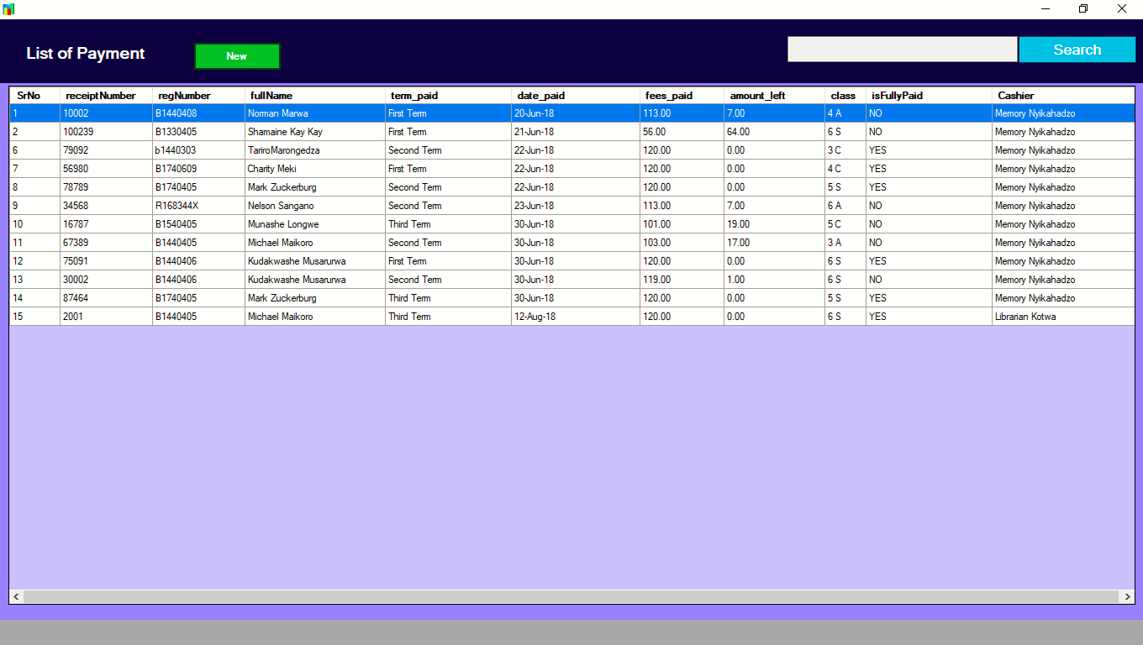

Objective 4: Displaying of fees in arrears
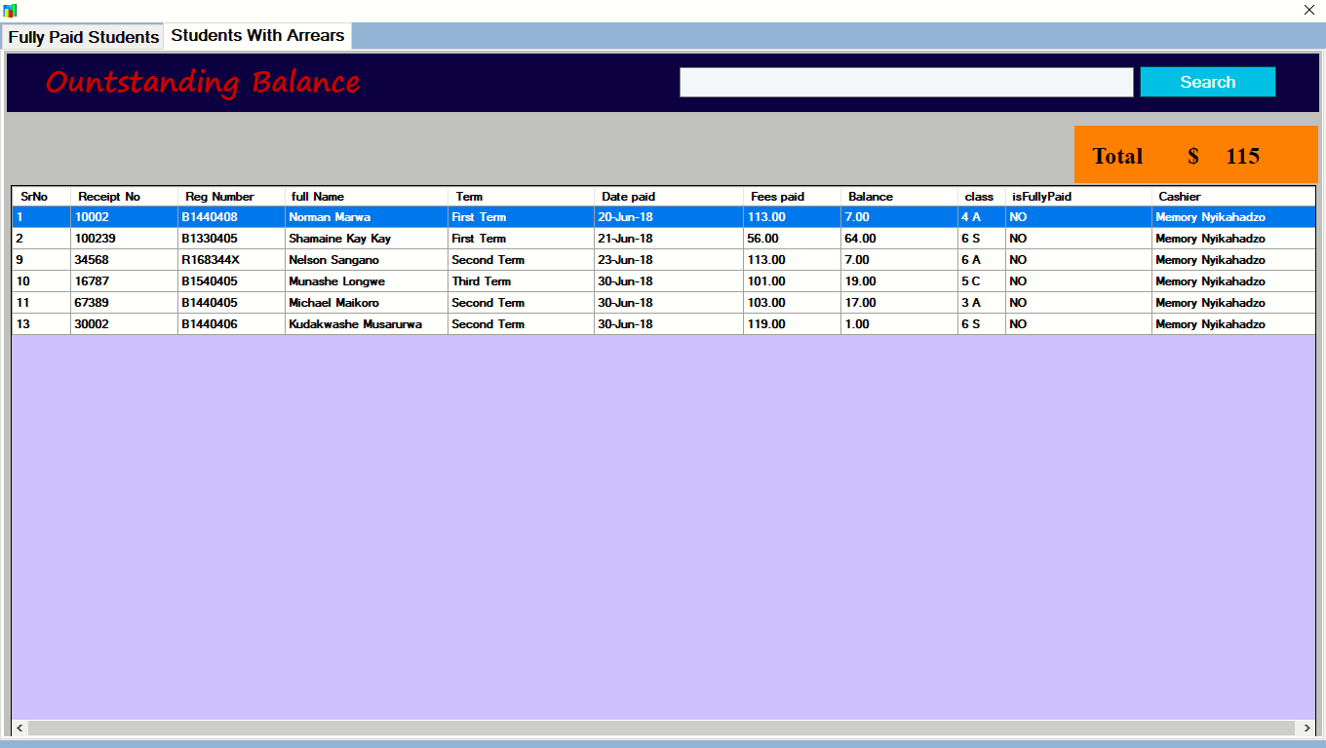

4.5. CONCLUSION
This chapter presented the snippet code for an automated school fees collection system for Kotwa High School. The chapter also looked at the system coding and implementation together with the various testing strategies used in system testing. Now that the system has been developed and tested successfully, the next chapter will focus on the implementation plan of the proposed system.

